How a Camera Works

You will need:
Camera
LED flashlight

https://www.youtube.com/watch?v=fSKqgZxM108

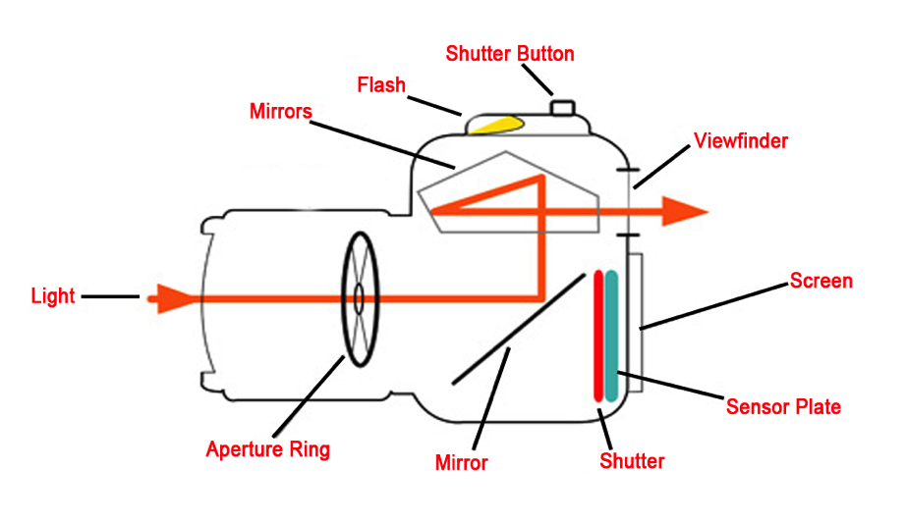

Practical Activity
- Following the instructions on this video, learn the parts of your camera
- Read the manual
- Take some photos!

