Aperture
Aperture means “opening”

In Photography, the aperture setting refers to how “open” the iris of the camera is.

The iris of a camera is just like the pupil in your eye- it opens and closes to control the amount of light that gets through to the recording sensors (in the olden days, it would have been film)

Aperture is known as “f-stop”. You may hear photographers talking about “stepping down” or “stepping up”. You may hear them say “opening up” or having the lens “wide open”. They are talking about aperture.

Opening or closing the iris has a very significant effect. It changes the depth of field. A shallow depth of field means you can only see so far, and the background will be blurry (great for portraits) A narrow depth of field means you can see all the way to the horizon- or further! (great for landscapes or travel photography).

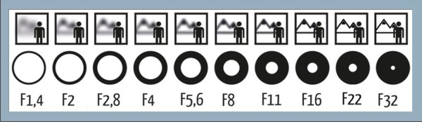

Watch Videos

https://www.youtube.com/watch?v=oobLnqpuAk4 1.10

https://www.youtube.com/watch?v=S4bjCeDPs2s 4.27

https://www.youtube.com/watch?v=6_B8pVoANyY
(about 3 minutes) Start at 3:50 End at 7:37 “what are you being crabby for”

Practical Activity Studio Session: Experimenting with Aperture:

There is a setting on your camera that lets YOU control the aperture, but the camera will compensate, so enough light gets through.
A- Nikon
AV- Canon
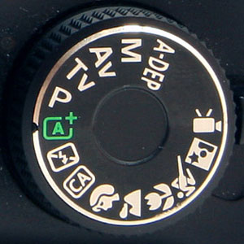

You will need:
Partner
Camera and Tripod
Background items, chair
Checklist (below)

1. In the studio, create a background, with some detail
2. Attach your camera to a tripod.
3. Set your camera to AV- aperture value
3. Sit your subject.
4. Use the zoom lens to find a desirable focal length (zoom)
5. Once you have set up, do not move the camera or change the focal length (zoom).
6. Take photos according to the checklist below.
7. Once you have analysed the photos, note the effect.

Aperture | Size of Iris | Check | Effect
F 1.4 | Wide open
F2
F2.8
F 5.6 | standard
F8
F11
F16
F22
F32 | Very small

